

Gaming Room

# **CS 230 Project Software Design Template**

Version 1.0

## Table of Contents

**CS 230 Project Software Design Template**1

**Table of Contents**2

**Document Revision History**2

**Executive Summary**3

**Design Constraints**3

**System Architecture View**3

**Domain Model**3

**Evaluation**3

**Recommendations**5

## Document Revision History

| Version | Date | Author | Comments |
| --- | --- | --- | --- |
| 1.0 | 09/30/21 | Elijah Carmichael | Updated Recommendation |

.

## Executive Summary

Due to the sudden rise in demand for mobile Application and web-based games, Creative Technology Solutions (CTS) has recently taken on a new client, The Gaming Room. The globe has experienced difficulties in developing a Lose It or Draw It games that serve in a multiple platforms. One of the common challenges is that the players were drawing images on an easel to help team members guess the puzzle, which led to the delay and less enjoyment of the game. Another difficulty is the sudden rise in demand experienced in the creative technology solutions where people requests new games that serve different environments. Creative technology solution has decided to develop software where Lose It or Draw It games are deployed in diverse playing environments. The Gaming Room will develop a web-based game that serves multiple running environments based on their current game, Draw It or Lose It, which is currently available in an Android app only. The application will render images from a large library of stock drawings as clues rather than a player drawing images on an easel.

## Design Constraints

When developing web-based software, there are few design constraints which you need to consider. Software designing is among the most relevant stage when developing an Application. Examples of these constraints are UML diagram, class diagrams, and ESS diagram. These examples are non-functional elements which enable the software developer to have a visual awareness of the required application. These constraints imply the main artifacts, actors, actions, classes, and roles, which letter allows for better understanding and documenting of the developed software. They further provide the developer with the programming tools required, technology requirement, and other important requirements from the customers.

## Domain Model

The most object-oriented programming principle applied in the UML diagram below is inheritance. It has enabled the singlectonTester class to perform activities and responsibilities inherited form the main class. The singlectonTester class inherits from programDriver class which is the main class as shown below.It has seven classes, namely; programDriver, GameService, Team, SingletonTester, Entity, Player, and Game. Entity class as a parent interface relates to the four child classes. GameService, Game, Team, and Player relates to each other in an association relationship where each entity depends the other one.

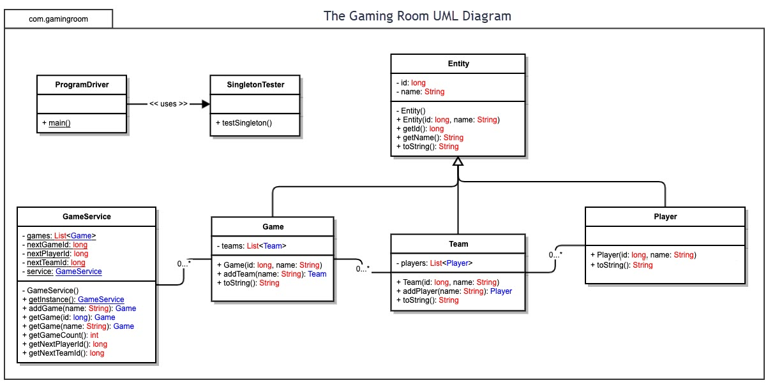

## 

## Evaluation

| **Development Requirements** | **Mac** | **Linux** | **Windows** | **Mobile Devices** |
| --- | --- | --- | --- | --- |
| **Server Side** | **Advantages**  It has various options for different web hosting requirements.  It is upgradeable.  **Disadvantages**  It is less preferred for web hosting services  **Characteristics**  It is popular in web hosting  Requires huge memory | **Characteristics**  Secured, most preferred.  **Disadvantages**  It is more difficult to find application to support the web hosting required needs.  **Advantages**  Security flaws are caught before they become an issue, it is the most preferred choice for web hosting services | **Disadvantages**  Has easy virus susceptibility.  Has poor technical support  **Characteristics**  It is dominant to the other platforms.  Close platform  **Advantages**  High resource requirements, less loading time, high comfort ability | **Characteristics**  It is more popular.  Has high portability.  **Advantages**  Has a wider reach, better compatibility, cost-effective  **Disadvantages**  It is highly selective to various smart mobile devices  Poor security |
| **Client Side** | Much time is required to access the software  High expertise required to develop software for clients who pertain to Mac.  It is expensive as the clients are charged monthly. | It is expensive as it’s not popular.  Requires high expertise as few applications are available.  Less loading time. | It is expensive as more resources are required.  Less loading time.  It requires a high expertise as it has high resource requirements. | It takes less time to load a page  It is common and therefore, it has high technical support for the clients  It is cost-effective |
| **Development Tools** | JavaScript , PHP programming language | PHP programming language | HTML/CSS  Java programming,  Net beans | Android programming, Android Studio |

Recommendations

1. **Operating Platform**: Windows Operating platform highly secured with less loading time and is relatively cheap. It is the recommend environment as it is common in developing web-based software. It is compatible and portable therefore suitable for the development of the Lose It or Draw It game.
2. **Operating Systems Architectures**: The Windows operating platform is a preemptive and reentrant operating systems designed to work with either symmetric multi processor or uniprocessor. It uses packet-driven I/O to process input/output requests. It has two main components, which are the user model and kernel model. The kernel mode has unrestricted access to the system memory and external devices while programs and subsystems in user mode are limited in terms of what system resources they can access.
3. **Storage Management**: Due to its high compatibility database management System is the best storage system that will work effectively and efficiently with Windows. It is easy to use and runs in multiple operating platforms. It is also highly adaptive, therefore suitable for the Windows.
4. **Memory Management**: Windows applies page file system technique where Windows will start removing pages of memory out of RAM and store them temporarily on the hard disk when the amount of memory for the Draw It or Lose It software exceeds the of RAM available. Another technique applied is the memory compression technique to accommodate the heavy use from the Draw It or Lose It software, which will increase the responsiveness of the operating system.
5. **Distributed Systems and Networks**: the distributed system will use hubs to connect multiple computers such that when one computer crashes, the game still operates by using LAN as the networking technology. Having LAN as our reliable network and Hub as the connectivity hardware, it will help the system to have a small outage overall. The hub will also serve as a repeater to amplify the signals that deteriorates when travelling for a long distance.
6. **Security**: Protection measures will be put into consideration to ensure the clients’ details are secured. Due to the high security capabilities for Windows operating platform, the user protection against intruders will be higher. The encryption of the clients’ particulars will be the basis of security for this application.